CSSA November 2021 Information & Workshop Equipment list
For our final workshop of 2021 we are each going to make a ‘folio’.
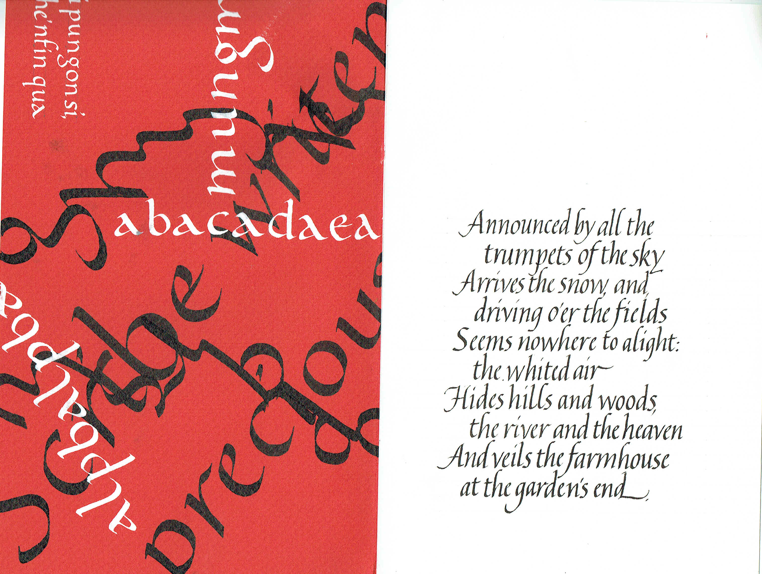

If you remember from last month’s meeting we talked about making a ‘folio’. You will need a piece of text to write – it can be as simple as a PANGRAM or something longer, if you are experienced, such as a poem or part of one. Not more than 6 to 10 lines (mine is 5 lines which have been split up to shorter length).

The RIGHT SIDE (the text page) is going to be solely your own work and you can either do it in advance or during the workshop. My folio is on A5 but you can do it on A4 too, Portrait or Landscape. Be sure to leave a good margin around your writing. If you are a more experienced calligrapher please try writing in a small nib such as 1 or 1.5mm for A5.

If you plan and practice this text piece before our workshop it will make it easier for you on the day. Make your layout simple – either justified left or centred and think about where it would look best on the page. If you are unsure then leave the FINAL piece to do at our workshop.

The LEFT SIDE or ‘design’ page will be our COLLABORATIVE work which we will all participate in, no matter what our skill level. There will be demonstrations, handouts and time for a little practice before you commit pen to paper. We will work on large sheets of Canson paper and to be cut up (when dry) to give each person a piece of original work to use.
AND IT WILL BE FUN – ALL SKILLS LEVELS WILL BE ABLE TO ACHIEVE – I PROMISE!
CSSA November 2021 Workshop Equipment list

This list applies to everyone as we will all be in it together.
Pens:
We will be using three different nib sizes, small, medium and large. Please bring with you:-
2 different Brause nibs sizes a medium size 3mm or 2.5mm and a small size 1.5mm or 1mm and pen holder (or 2).
A couple of Automatic pens in large sizes IF you have them. There will be a selection of Automatic Pens for us to share on the day.

Paper:
A 4 and/or A 3 practice paper – good copy paper or cartridge paper or any paper which won’t bleed with your ink;, AND:
A4 size ‘good’ paper to write your text piece on if you are doing it at the workshop.
The CSSA will provide several large sheets of Canson Mi Tientes paper for our collaborative work.

Ink:
Everyone: - Sumi ink or your favourite BLACK ink.
CSSA will provide all the inks and gouache you will need for the collaborative work.

Odds and Ends
If you have this equipment please bring it along and there will also be some extras to share. Cutting mat, steel ruler and craft knife; glue stick or PVA adhesive and brush; a bone folder.

Other stuff: now known as your Usual Kit Bag
Everyone needs to bring - Slope board (if you have one); ruler; protractor; eraser; small water container (like a small yoghurt pot); sharpened Hb pencil or mechanical pencil; some kitchen roll for pen wiping; old toothbrush to clean your nibs; plastic sheet to cover your work table; apron to cover your clothes; - we might be splashing the ink around!!! Plus $5 for your workshop fee.

Please don’t forget to let Vanessa know that you are coming and book your spot so that we can have the room set up.
Contact Venessa directly on vanessa.kingsborough@gmail.com
Questions for Joy on Joy <gjvadams@gmail.com>
Questions for Anne on elantay@westnet.com.a

