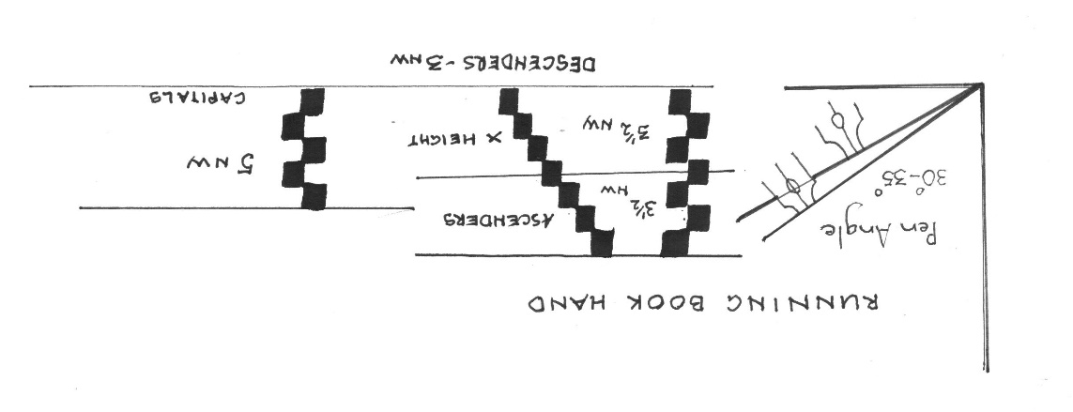

MargaretLewis

IT IS AN IDEAL SCRIPT FOR calligraphic pieces because letters are penned using the least amount of strokes to form the shapes.

**SUITABLE FOR ALL SKILL LEVELS.** Beginners especially welcome.

LEARNING A NEW SCRIPT, OR REVISING, IS ALWAYS AN ESSENTIAL PART OF OUR CALLIGRAPHIC JOURNEY.

RUNNING BOOK HAND is probably a new script to many of you.

It is a modern script using three Manuscript styles as a basis for the letters.

THE UPRIGHT ROUNDED FORMS OF FOUNDATIONAL

THE SPRINGING ARCHES OF ITALIC

THE TALLER ASCENDERS OF CAROLINGIAN

I WOULD LIKE YOU TO WORK WITH NIBS, OR PARALLEL PENS ABOUT 3mm wide or even a little LARGER if you can. Working large enables you to see and understand the nuances of any calligraphic hand.

**MATERIALS**

Slope board, if you have one. Ruler, pencil, eraser, water jar. Ink, gouache to suit writing tool, or parallel pen. Several pages ruled, ready for use, using the guide below. Spare blank paper.

**CSSA Sunday Workshops**

**JUNE and JULY 2021**

**RUNNING BOOK HAND**

**JUNE– miniscule and majuscule letters**

**JULY – continue with letter forms**

**Writing, layout , letter spacing, joining and some alternative strokes.**