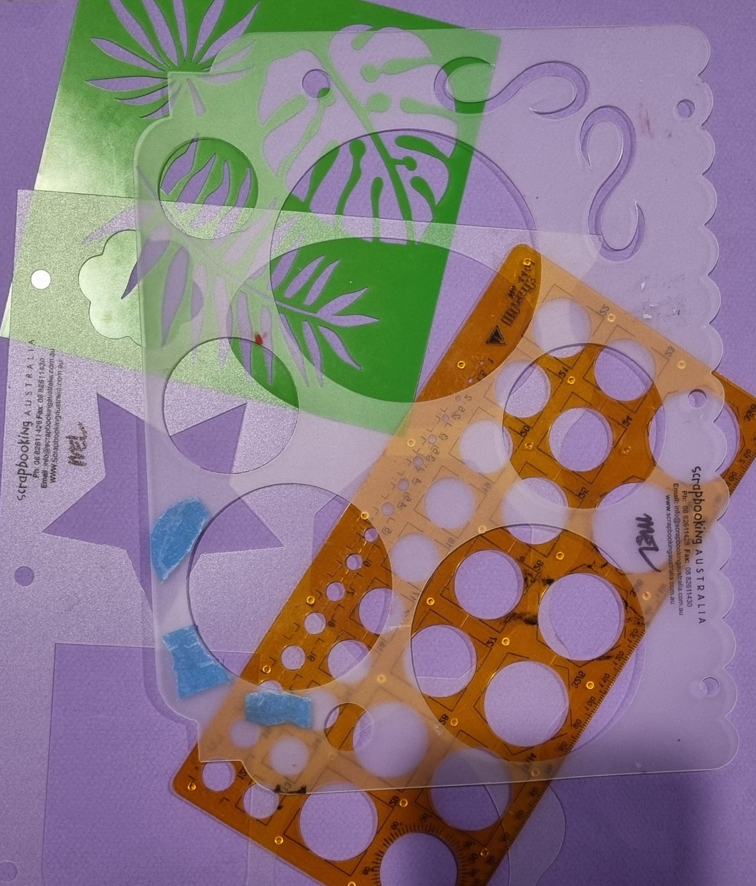
Whoops! Forgot to include this in the materials list for the Embossing on Paper workshop on Sunday 24th March.

If you have any THIN STENCILS please bring them.
Thick ones such as Friskars and others will not work, but you could use them to trace shapes onto card for cutting.

