Embossing on Paper
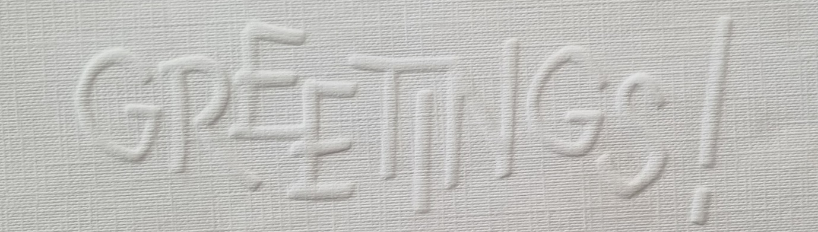
Workshop on Sunday 24th March 2024
We will be experimenting with various papers and thin card.
Techniques will be simple and do not have to include lettering.
MATERIALS LIST
small cutting mat, steel ruler and good sharp cutting blade
tracing light ‘box’ if you have one. (Some of you have A4 USB charged flat ones.)
pencil, ruler, eraser. Glue stick
embossing tool – two sizes or one double ended tool (see examples below)
Various small pieces of watercolour paper both hot and cold pressed if you have them. Card or photo size is okay.
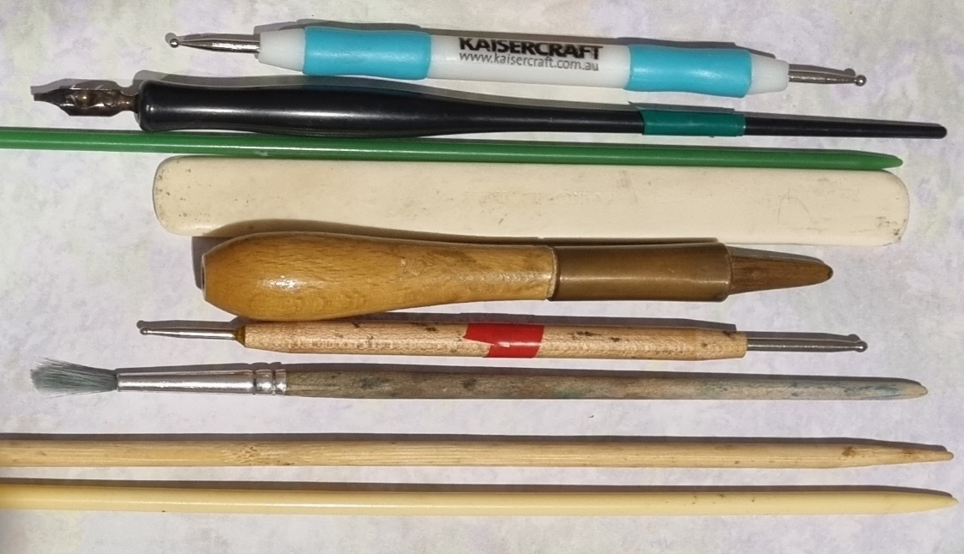
Any thin stock card, or pieces of canson, etc.
EMBOSSING TOOL EXAMPLES
You only need two small sizes
Plastic or wood nib holder
Bone folder ( pointed end is better)
End paint brush (paint removed)
Plastic knitting needle
Skewers (bamboo or wood)
Gem stone

I have 4 Kaisercraft embossing double ended tools to sell. If you wish to purchase one please send me a message on my phone. Margaret. 0427791742 $4 each

